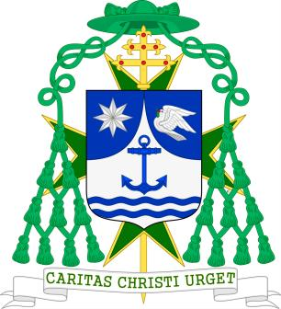

Dear Confreres and Consoeurs,

Our Spiritual Advisory Council underlined the importance for our Order of its ecumenical nature, in particular to promote and participate in moments of prayer for Christian Unity and other ecumenical and charitable initiatives.

Traditionally the date for the celebration of the Week of Prayer for Christian Unity in the Northern Hemisphere runs from the 18th to the 25th of January. We will be holding an ecumenical service at the Sacro Cuore church dedicated to Saint Lazarus. Another celebration will take place on the 23rd in Terrasini.

Inspired by the story in the Acts of the Apostles of Paul's shipwreck in Malta (Acts 27, 18-28,10), the Christian churches of Malta and Gozo, offer us a narrative of divine providence and human welcoming. The theme for this year is "They treated us kindly" (Acts 28.2). It is an attitude that literally means "philanthropy", that is, love for humanity, but also benevolence, welcoming and hospitality. "Hospitality - the Christians of Malta tell us - is an essential virtue in the search for unity among Christians. Its practice drives us to greater generosity towards those in need. The people who showed kindness to Paul and his companions did not yet know Christ, yet it was because of their "unusual kindness" that a group of divided people was gathered in unity. Our unity as Christians will be revealed not only through the hospitality we show to others, albeit important, but also through loving encounter with those who do not share our language, our culture and our faith. In stormy travels and fortuitous meetings in life, God's will for his Church and for all humanity reaches its fulfilment; as Paul will proclaim in Rome, God's salvation is for everyone (Acts 28, 28) ".

We Christians must show this "philanthropy" towards our neighbour who knocks on our door in search of help, protection and care, and especially towards refugees, foreigners, migrants, Christians and exponents of other persecuted religions.

On the occasion of the World Day to Combat Leprosy, established in 1954 by French writer and journalist Raoul Follereau, our Order is committed to ending all prejudice and discrimination, bearing in mind that one of the fundamental needs in the lives of those who experience this disease, apart from medical treatment, is for love and fellowship.
We Christians of different churches have unfortunately accumulated a heavy burden of mutual distrust over the centuries, but we thank God for the birth and growth of the Ecumenical Movement. Our meeting with Christians of other traditions and our common prayer for unity encourage us to seek mutual forgiveness, reconciliation and acceptance.

Let us pray for the gift of visible unity among Christians with constant faith, tireless patience and watchful hope, trusting in God's loving providence.

I wish you a happy New Year in peace, justice, harmony and fraternity.

Monreale 12 January 2020

Feast of the Baptism of Jesus

X Michele Pennisi, Archbishop of Monreale and Grand Ecclesiastical Prior MHOSLJ

