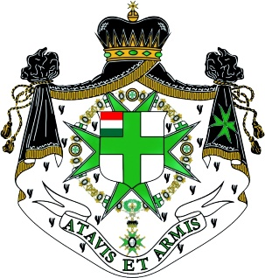
The Millitary and Hospitaller Order off
Saint Lazarus of Jerusalem
Grand Priory of Hungary

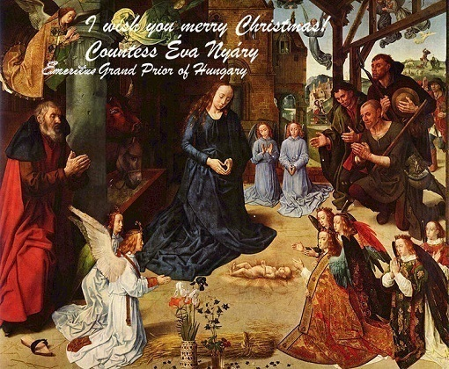
I Wishes all the members of the Order a Peaceful and Joys Christmas
and good wishes for the New Year.
Countess Éva Nyáry
Emeritus Grand Prior of Hungary



