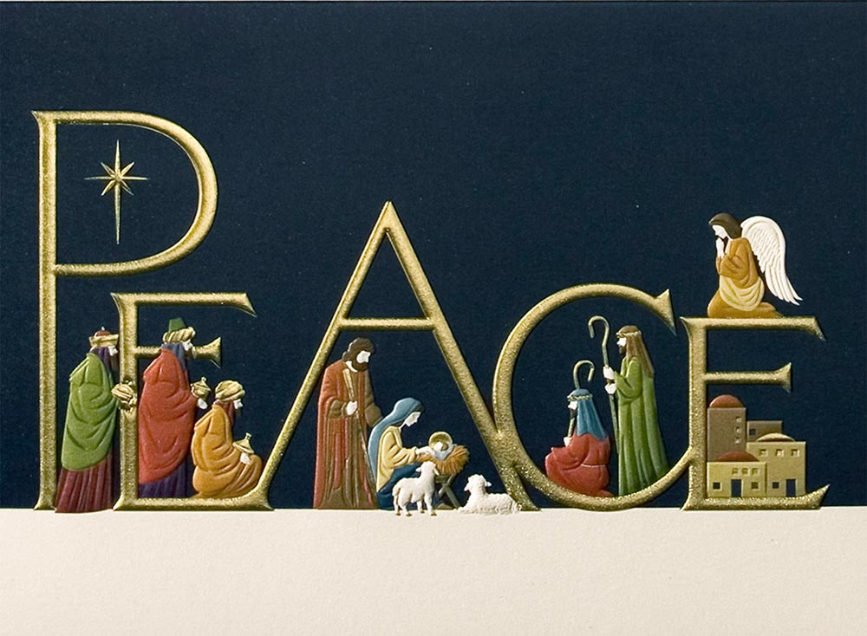

The Grand Baillie and members of the
Grand Bailiwick of Scotland
Wishes all the members of the Order a Peaceful and Joys Christmas
and good wishes for the New Year.

