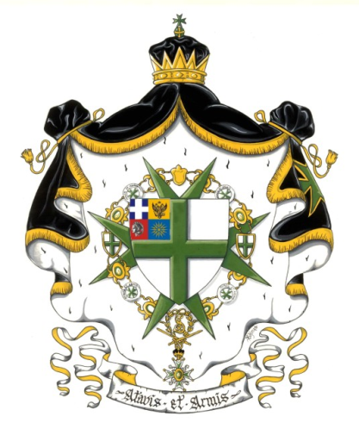

The Grand Prior and the members of the Hellenic Grand Priory
of the Order of Saint Lazarus of Jerusalem
Wishes to all members of the Order and their families
A very Merry Christmas
And
A Happy Healthy and Prosperous New Year

The Grand Prior
Spyridon D. Strangalos, GCLJ

