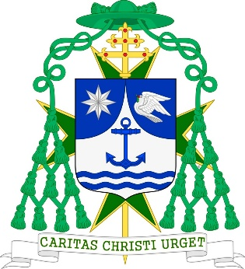

Monreale, September 2019

I join in the condolences of the Military and Hospitaller Order of Saint Lazarus of Jerusalem for the removal from this earthly scene of the Grand Commander Emeritus of the Order and Chairman of the International Grand Bailiwick, Ronald Hendrikus Maria Hendriks, GCLJ, who distinguished himself through a series of important humanitarian involvements and engagements in the health sector and held important positions within the Order, in which he played a key role by saving and reorganizing the Malta Obedience of the Order and in the reunification of the Obediences of Malta and Paris.
The Lord who raised Lazarus from the dead and who welcomed poor Lazarus into the bosom of Abraham has rewarded our confrere with eternal life; he who recognised Jesus present in the sick may now be welcomed into His Kingdom of light and peace so that he will enjoy eternal rest in Heaven.

Michele Pennisi, Arcivescovo di Monreale
Gran Priore Ecclesiastico dell’ Ordine Militare Ospedaliero di San Lazzaro

