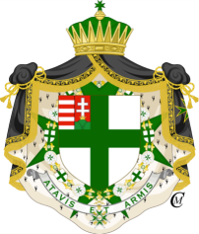
The Military and Hospitaller Order of Saint Lazarus of Jerusalem
Interim Grand Master: H.E. Don Francisco de Borbón Graf von Hardenberg
Grand Priory of Hungary
Grand Prior of Hungary: H.E. Dame Countess Éva Nyáry DGCLJ-J, DMLJ, SMLJ,

We respectfully invite you
The Solemn Investiture & Gala Dinner of the Grand Priory of the Hungary is being held on Saturday 07th April 2018 at the Hotel Gellért, Budapest.

07. April 2018.

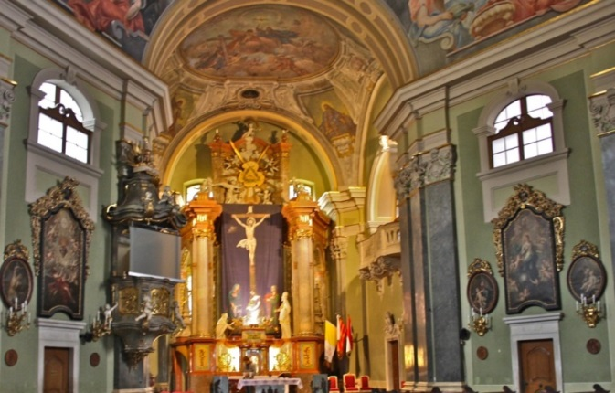
INVESTITURE AND HOLY RIGHT PROCESSION
The Investiture ceremony will take place in the St. Anna Churc in Budapest 10.00 h – 12.30 h

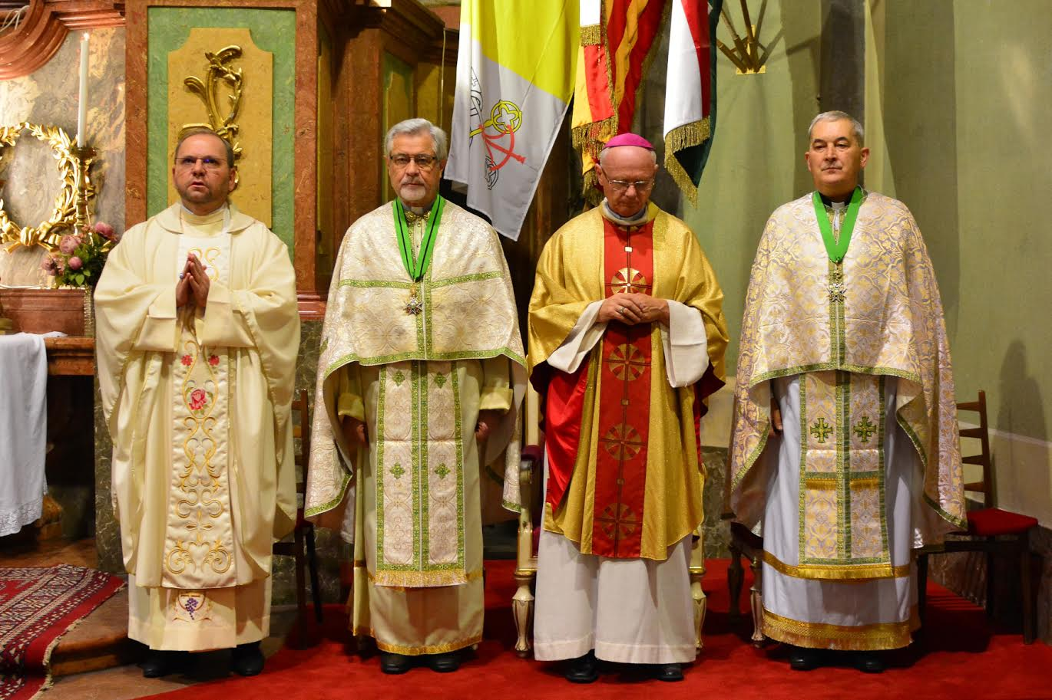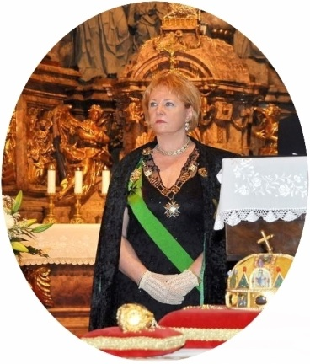
The holy mass was celebrated by H.E. Dr. Lajos Varga bishop, and H.E. Dr. György Herdics honorary abbot - Grand Prior of Hungary Countess Éva Nyáry DGCLJ-J

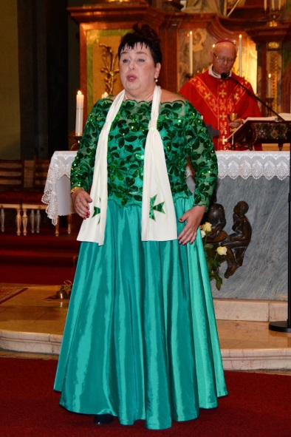
Opera singer Júlia Kunsági CLJ St. Lazar Section - children band

Dress Code for Investiture:
Knights: Uniform or dress suit, mantle, decorations and gloves

19.00 – 24.00 Gala Dinner at Hotel Gellért - Budapest
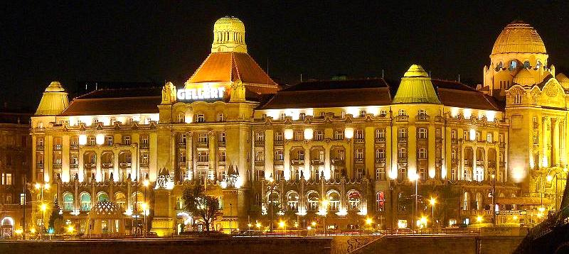

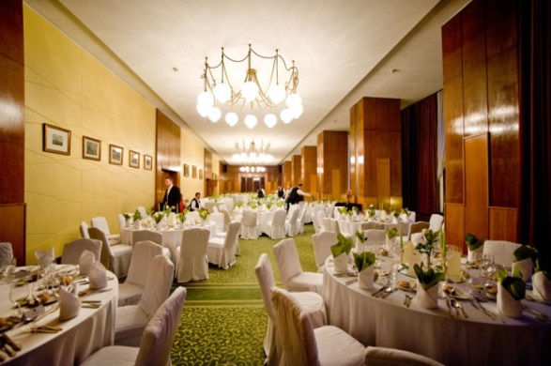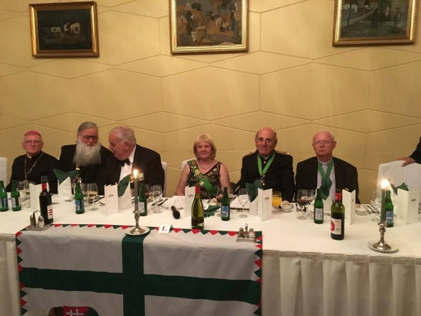

Registration
The Grand Priory of Hungary kindly asks you to confirm your participation
28. March 2018. st of at the event by e-mai to the following
address: nyaryeva@gmail.com

Registration fee is 120.- EUR /prs.
Please make the payment of the participation fee to:

Raiffeisen Bank Zrt., Budapest
IBAN: HU33 1201 0501 0015 6680 0010 0009
SWIFT: UBRTHUHB

Dame Countess Éva Nyáry DGCLJ-J. Grand Prior of Hungary

